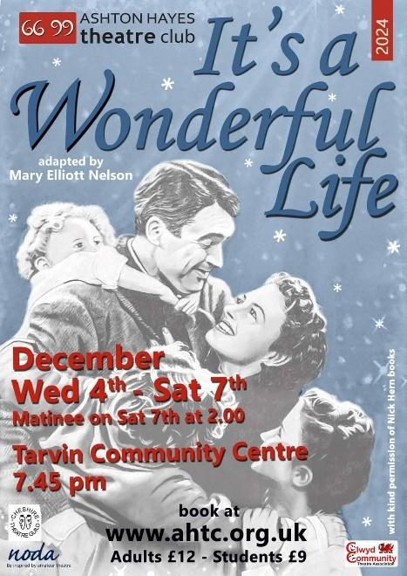**AMATEUR THEATRE REVIEW: It’s A Wonderful Life – Ashton Hayes Theatre Club, Chester.**

I don’t know about you, but when we get to the month of November, I can’t wait for the joys of Christmas to begin. From the classic music to the sparkly decorations to the festive food and drink, I am ready to be immersed. And the Christmassy entertainment is right up there. I had very recently watched the film ‘It’s a Wonderful Life’ so when the opportunity to see the play came up, I jumped at it!

This heartwarming tale was brought to the big screen in 1946 by director Frank Capra and with the legendary actor James Stewart and a strong supporting cast, they all created something magical. It is a film so beloved that even today, as it edges closer to its 80th anniversary, there are special viewings at cinemas for those that watch this film as a Christmas tradition, or first timers wanting to know what the hype is all about!

Bringing a story so well known to the stage is a challenge that Ashton Hayes Theatre Club chose to take on, and the task to execute this fell to director Simon Jones, returning to the world of directing after some time off writing and acting. Well, what a comeback! With a cast of 11 talented actors, many of whom played multiple roles, and a brilliant production team, Simon’s imaginative decisions in the staging of the play were inspired.

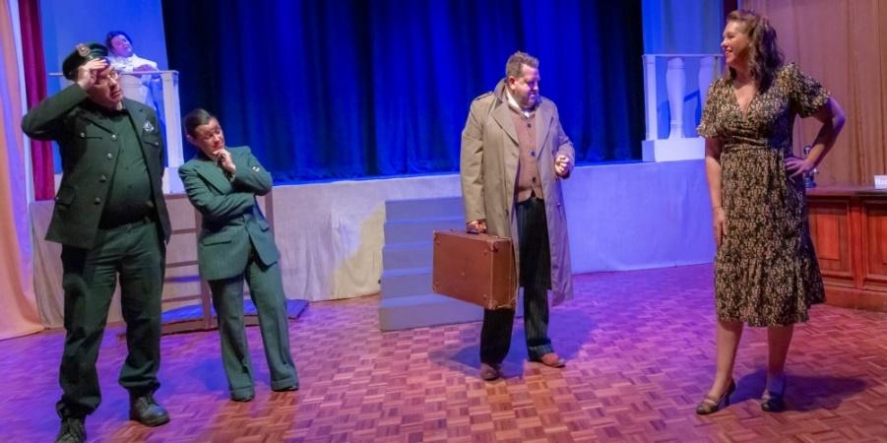

Next time you read that a play is going to be in a community centre hall, do not be sceptical because a creative vision can do wonders to transform that space. As soon as I walked in, I saw the walls adorned with fabric to hide the white paint underneath. The stage was extended to the floor space below it, with various set pieces for the different locations where the scenes would play out.

The story begins on Christmas Eve, and the cast take their positions on the extended floor stage. Whilst looking to the heavens, we hear their thoughts then see them speak and all are praying for a man named George Bailey, who is stood on a bridge, with a look of deep sadness. Their collective voices reach the ears of three angels who walk out on the raised stage.

A big shout out to the costume designer (also impressively playing three characters with one of the quickest costume changes I’ve seen and yet still walked out on stage with grace), Yvette Owen for the fabulous white trouser suits that helped elevate and complement the actresses’ performances. I liked the interesting detail of our winged angels’ costumes, played with a dignified presence by Tina Wyatt and Vanessa Duffy, having silver trim on their jacket lapels to Clarissa, played by Andrea Jones without any silver. The innocence, enthusiasm and wonder in Jones’ performance when Clarissa volunteers to answer the town people’s prayers really sucks you in as the audience, and leaves you rooting for her to not only save George, but finally get her wings! Director Simon wanted to keep heaven and the angels separate from what was happening with George on earth, (until Clarissa comes down to help him) and the use of white lighting really helped to enhance this. It meant that the angels were truly watching over George down in the town of Bedford Falls, a motif that is successfully used throughout. 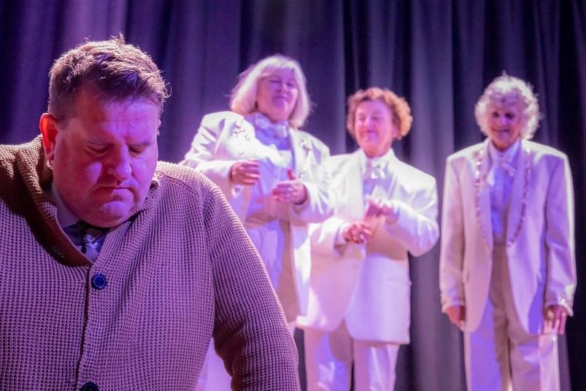

I was intrigued to see if the play would feature the flashbacks in the film that explain how George Bailey’s life experiences lead to him standing on that bridge in complete turmoil. And to my pleasant surprise, it did! My brain was connecting a lot of dots with the film during these sections, but the way the sequences were staged meant that even the novice viewer could keep up. The narration from cast members and the dialogue within the scenes helped to paint the picture that we were going back in time and getting snippets of George’s history. I like that everything plays out under the watchful eye of Clarissa up in heaven, getting as much intel on George as she can. You might think seeing grown adults playing children to teenagers to young adults might pull you out of the scene, but I was really impressed as I could see the actors growing up in front of my eyes, from their speech to their mannerisms, so I was able to stay connected with them in the scene. And to that, a special mention to Jac Wardle’s performance of a 9-year-old Harry, George’s younger brother - exceptional!

Dave Rogerson’s portrayal of George Bailey through the years really captures the spirit of James Stewart’s well-known performance. From being a young man with a zest for life and adventure that would take him far from his hometown to a man approaching his 40s who seems a shadow of his former self, Rogerson pitched the emotional journey perfectly at every turn. I actually forgot where I was for a second as he talked about his dreams for the future, because I was getting excited for him and yet I knew where fate would take him.

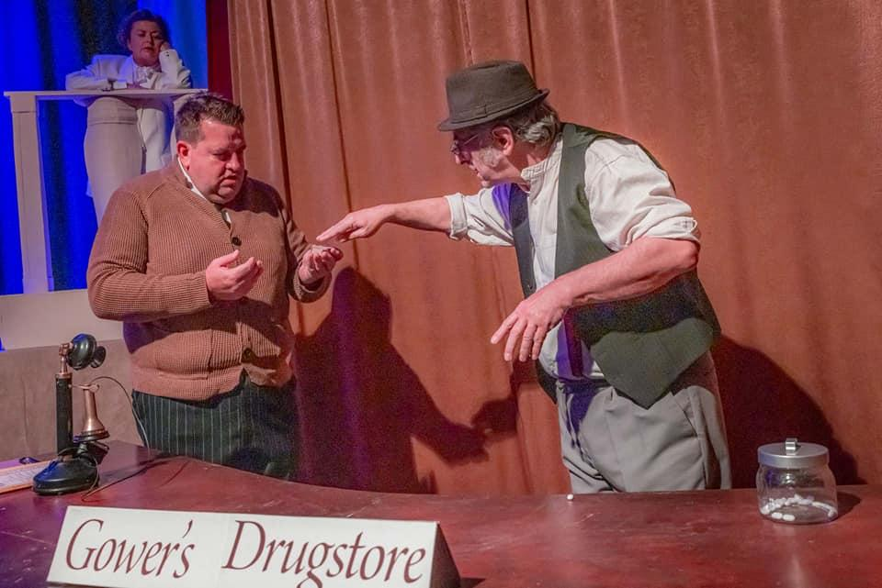

The wooden desk/counter set, which doubles (or is it triples…) as a chemist, family business and bar, is where we mostly see George helping people in the town. In its various guises, we see him as a teenager saving the reputation of Mr Gower by spotting a fatal mistake with a medication prescription, and the emotion portrayed by actor John Booth, from being the sad, grumpy man to one who owes his life to another was clear to see. This is also when we first encounter Mary but her being younger than George is so very obvious when they are children so he doesn’t notice her.

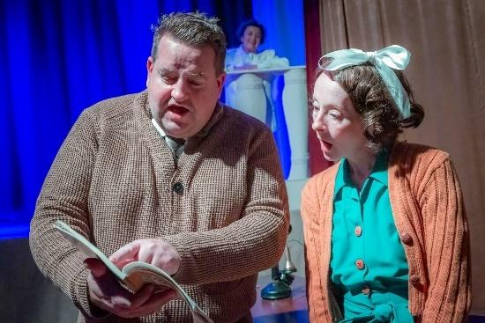

As young adults, George and Mary are reconnected and enjoy a night dancing at a party where George starts to notice her as someone of potential interest, meanwhile she has loved him practically her whole life! The chemistry between the two actors is palpable and after leaving the party, they take a moonlit walk together where the iconic line is uttered by George, **“*You want the moon? Just say the word and I’ll throw a lasso around it and pull it down*.”** And Matthew Parry and James Clifford’s lighting team actually gave us a moon, which put a big smile on my face! This precious moment is interrupted with terrible news, and is one of many pivotal moments in the trajectory of George’s life. Up till now, he worked at the family business, Building and Loan, but after what happens with his father, and the threat of Bedford Falls’ richest man, Mr Potter, played so brilliantly dastardly by Stuart McNeil, who gives us a good villain to boo in the bows, George is effectively forced to abandon his travel and college plans to run the company.

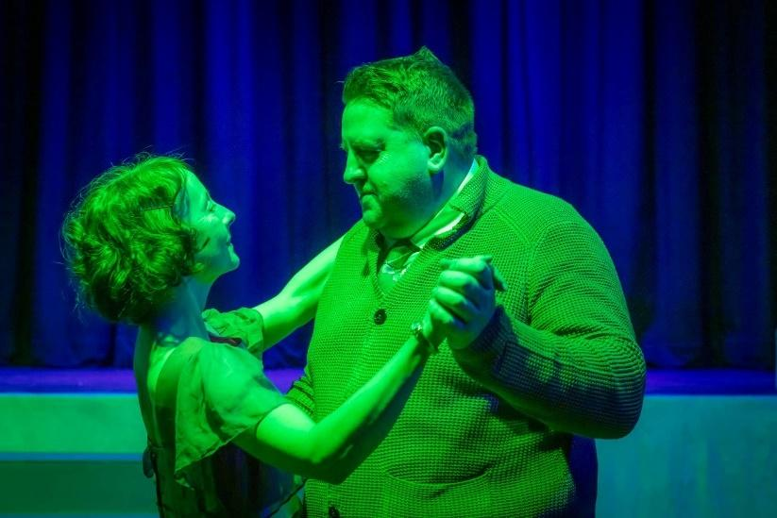

Over the course of their wonderful love story, George is the man of the people, working hard every day, but Mary is his rock. The elegance and strength that Emily Duffy brings to her portrayal of Mary just makes you really like her and want to be her friend. A truly dependable woman, which we see demonstrated when George suffers yet another setback with the company, and she gallantly offers their personal honeymoon money to help the townsfolk and save the company from Mr Potter. She then surprises George with the run-down old house on a rainy night, thank you to the sound engineer Andy Walker for bringing the rain effects, I was literally looking for my umbrella! This is when the back of the stage is utilised, curtains parting to reveal a candlelit dinner as Mary sells her idea for making this their home. In the second act of the play, there is a lovely surprise when the curtains open once again to reveal a beautifully decorated Christmas tree, sparking an involuntary audible gasp of awe from the audience, including me!

Seemingly innocuous decisions set in motion consequences that George could have never foreseen. Hearing loss in one ear as a child when he saved his brother Harry from drowning would make him medically exempt from enlisting in the war years later, where Harry would become a war hero; his agreement to work in the family business with the plan that Harry would take over after college and George could finally travel were scuppered when Harry met a girl, married her and his father-in-law offered him a stable job; a missed opportunity when did not take his friend Sam Wainwright, (played by Nita Lawton, who took on the role of a man and she owned it) up on his offer to invest in his business that resulted in big money success; the recurrent presence of Mr Potter trying to secure the company and then the event that ultimately breaks George.

George’s Uncle Billy is a character that an audience will remember once the show is over. Mike Howard plays him with a sort of chaotic energy, spirit and pure heart that makes you feel protective of him. So, when he invertedly gives $8000 meant for the bank to Mr Potter, McNeil giving a sneaky smirk as he pockets the money and leaves, Uncle Billy is left searching in distress, and we are distressed with him. And then he has to tell George what has happened. The events of the night, which include shouting at a teacher on the phone, shouting at his daughter and being punched in the bar, culminate with us being back to where the play started, George standing on that bridge in the depths of despair, and now we understand why. Then Clarissa makes her acquaintance with him but with all the life and vigour he had gone, he says something that gives Clarissa an idea, which she gets approval for by way of a nod from the more senior angels up in heaven (on stage!). 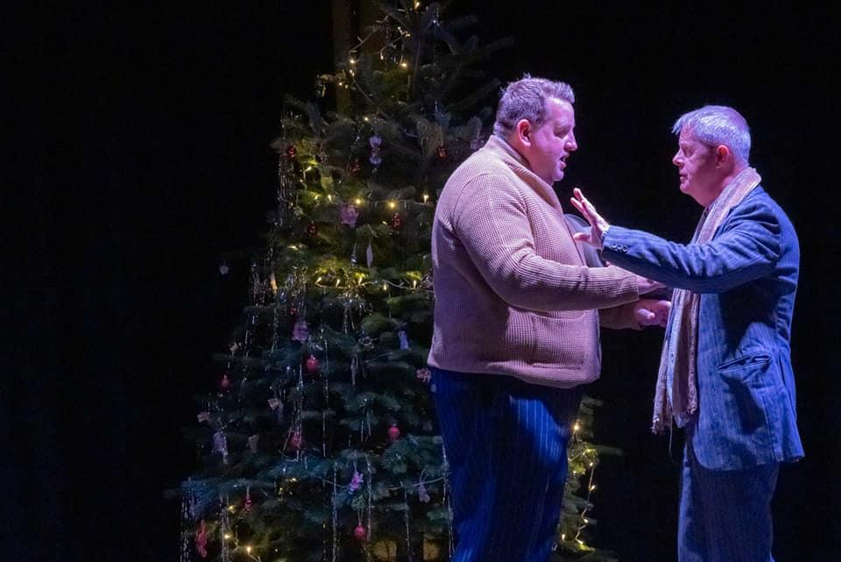

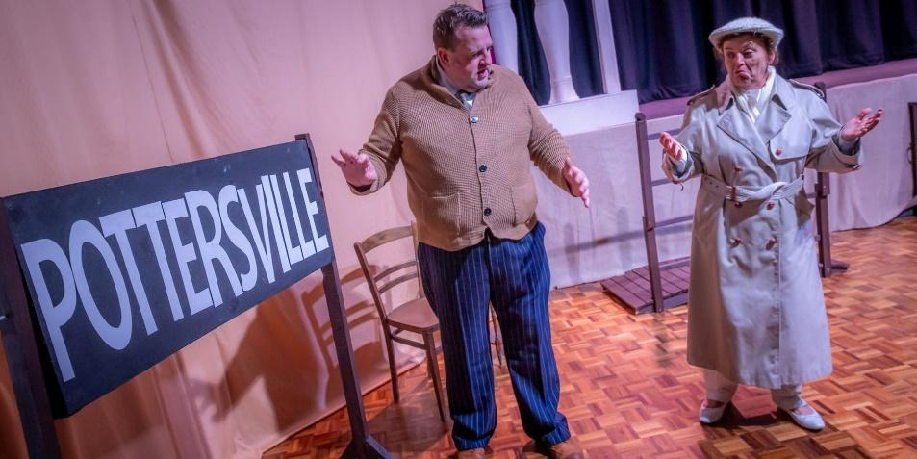

By wishing he had never been born, Clarissa grants him this. The lighting and sound departments team up to create some more magic with the sound of thunder and lightning filling the room as the colour red flashes signifying that we are now somewhere unfamiliar. The *Bedsford Town* sign has been changed to *Pottersville*, a handy prop that can be flipped depending on where we are in the story. Let me take a moment to give the cast and crew a round of applause on the set construction and props. I was a particularly big fan of the telephones that were appropriate of the time, the hot-desking nature of the phone used by several characters - I could picture Mr Potter in his office when he uses it, and then it being a public phone when Sam Wainright and Harry and his wife use it. Also, the sound of the phone ringing and stopping once picked up – sometimes it’s the little things that are satisfying!

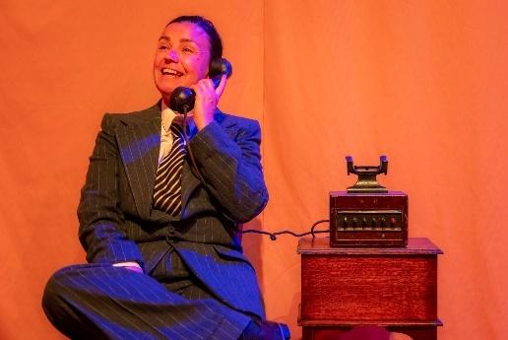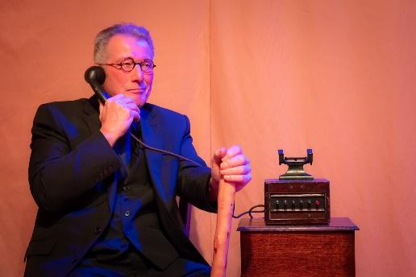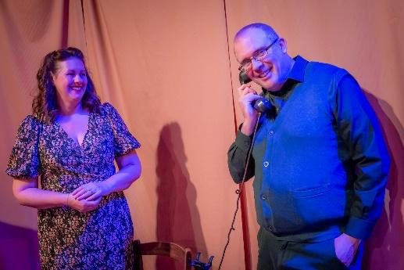

As we discover this new place with George and Clarissa, the panicked performance from Rogerson against Jones’ stable, lesson teaching is a nice contrast. Director Simon then uses the halls space, turning it into a 360 experience as George runs from stage, down the side past the seating area, all the way round the back of the seating area and up the other side then back on to stage, all the while shouting in fear at all the changes that have happened in town, unable to understand why and then finally Clarisa makes him understand. He may have led a much simpler life from the one he dreamt of but the life he lived impacted the whole town and without him, it literally fell apart.

George’s realisation and acceptance of this brings him back to reality, where all he wants is his wife, kids and old life. We get the same 360 experience but this time, we hear the joy in his voice as everything is back to normal. He rushes home to be met by the community coming together for him after having prayed for him, roused to action by his formidable Mary to raise the lost money, even Mr Potter puts his hand in his pocket! George hugs her and looks at the truly wonderful life he has when a beautiful rendition of Auld Lang Syne starts being sung on stage. I hear audience members around me joining in; it really is a song that brings people together. The sound of a bell during this tells us that our favourite angel finally gets her wings!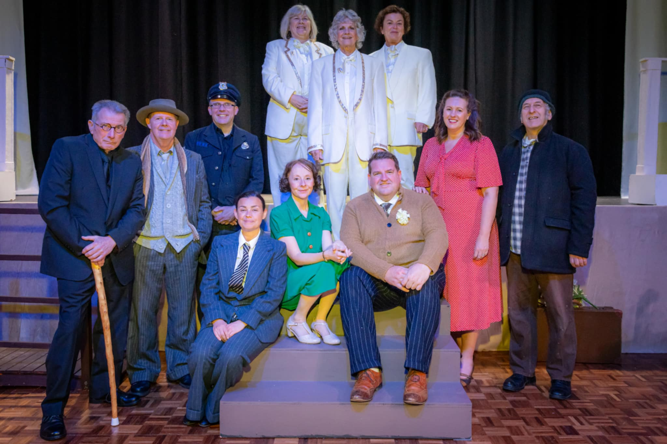

For a Christmas classic, it does have a dark undercurrent theme that is talked and hinted at from the word go, but I guess that is quite usual for a Christmas story – we have to see and feel the sadness and despair so that when the good and hopefulness is uncovered, it helps us, as the audience to take that lesson home – it won’t always be this bad, keep going and the good times are coming.

Thank you to the Tarvin Community Centre for hosting us. And thank you for the warm welcome Ashton Hayes Theatre Club - well done for doing this wonderful story justice, sending us off with our hearts warmed, and Christmas cheer to spread to all that we meet (and tell them to keep an eye out for this theatre clubs’ future productions!) And to have a Merry Christmas!

Reviewer: Bwalya Mutale-Kibaris – AMT Productions

Date: 05.11.24

**If you want to see Ashton Hayes Theatre Club’s next production ‘The Incident Room’ - June 18th -21st at Tarvin Community Centre. Please follow the link below to book your tickets. https://www.ahtc.org.uk/box-office**