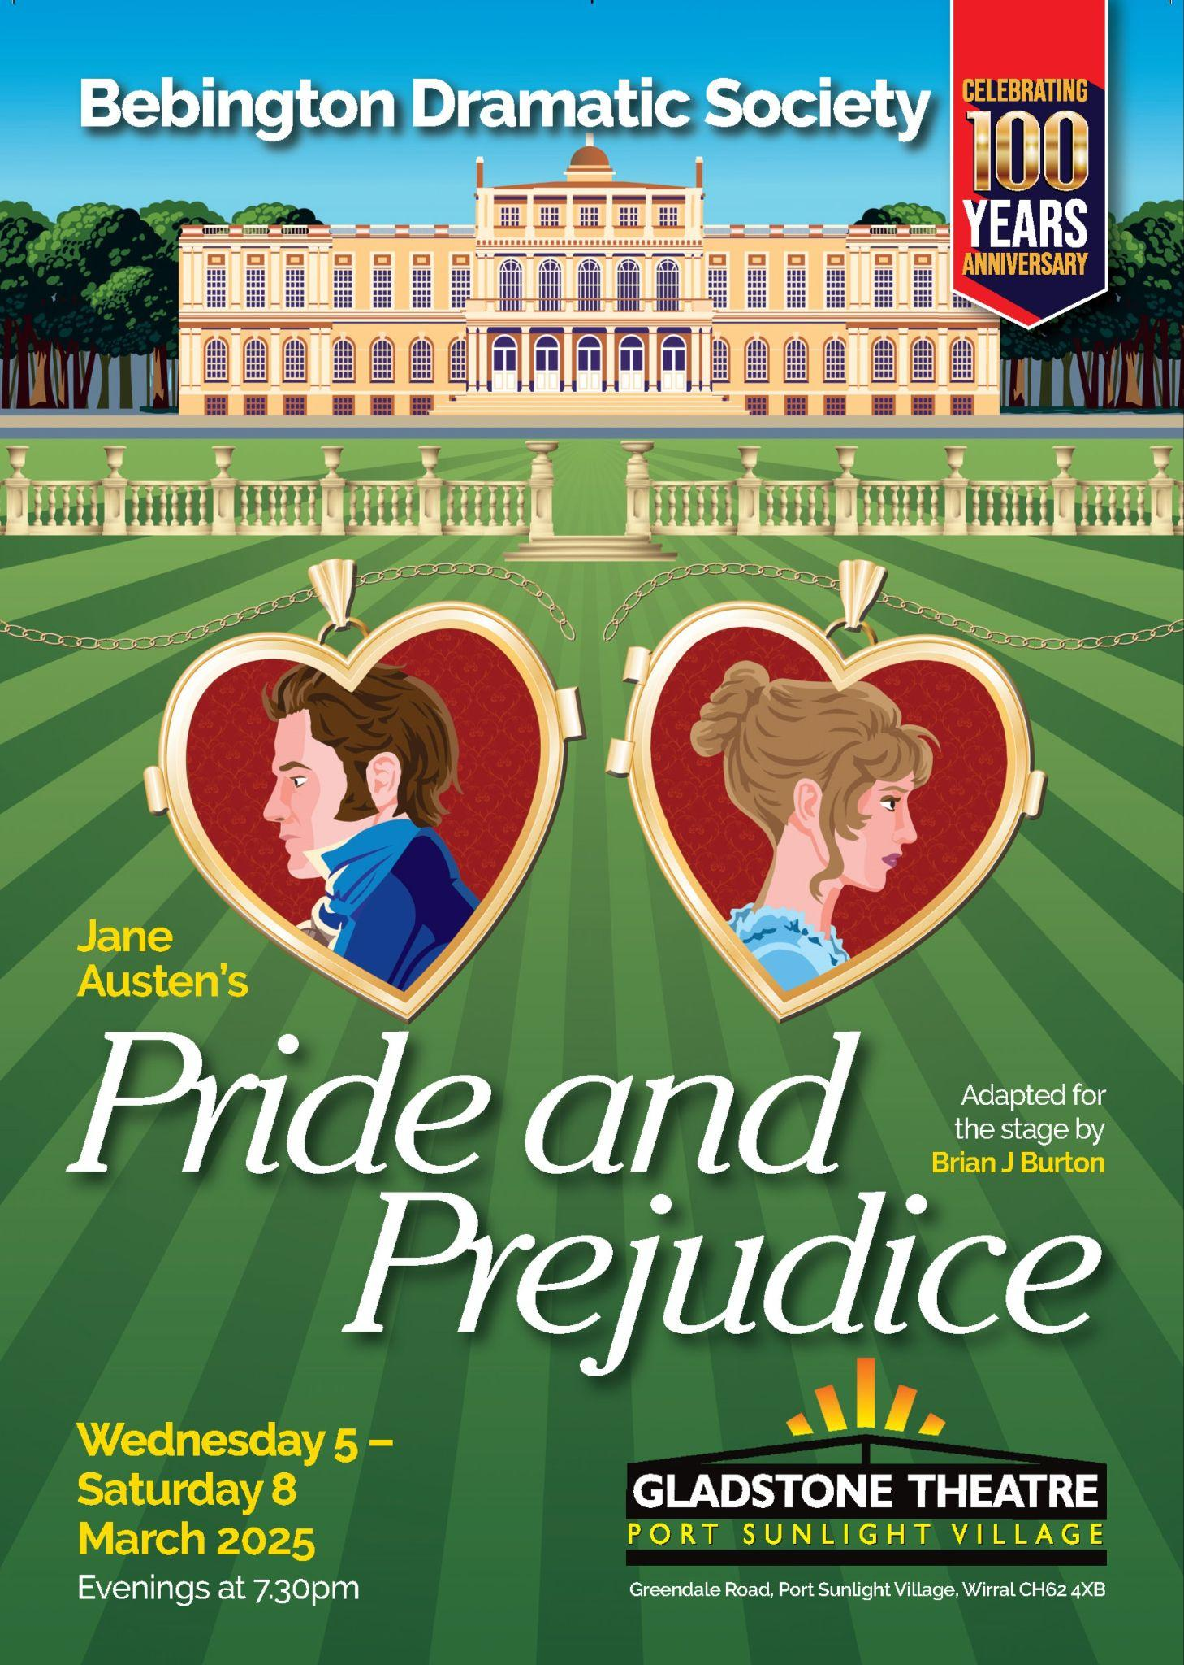

**AMATEUR THEATRE REVIEW: Pride and Prejudice – Bebington Dramatic Society**

***“’Tis a truth universally acknowledged that a single man in possession of a good fortune, must be in want of a wife.” So begins the most beloved of Jane Austen’s novels and one of the most famous love stories in the world. At a time when men hold all the cards, the only economic choice for Elizabeth Bennett and her four sisters is a suitable marriage. But when Elizabeth meets the wealthy and arrogant Fitzwilliam Darcy, first impressions are not favourable. Sparks will fly…  
  
Based upon Jane Austen’s novel about five sisters in Georgian England. Their lives are turned upside down when a wealthy young man and his best friend arrive in their neighbourhood. Adapted for stage by Brian J Burton.***

‘Tis also a truth universally acknowledged that a beloved classic can still surprise and delight, whisking audiences back in time with beautiful storytelling, making us fall for Fitzwilliam Darcy all over again. I had the pleasure of watching Bebington Dramatic Society’s retelling of Jane Austen’s classic, Pride and Prejudice at the Gladstone Theatre, Port Sunlight. The production had its audience enchanted from start to finish, bringing Austen’s wit and romance to life with charm, humor, and elegance. The talented cast, under the direction of Jane Wing and ___, captured the heart of the story, delivering memorable performances that had the audience laughing, sighing, and utterly captivated.

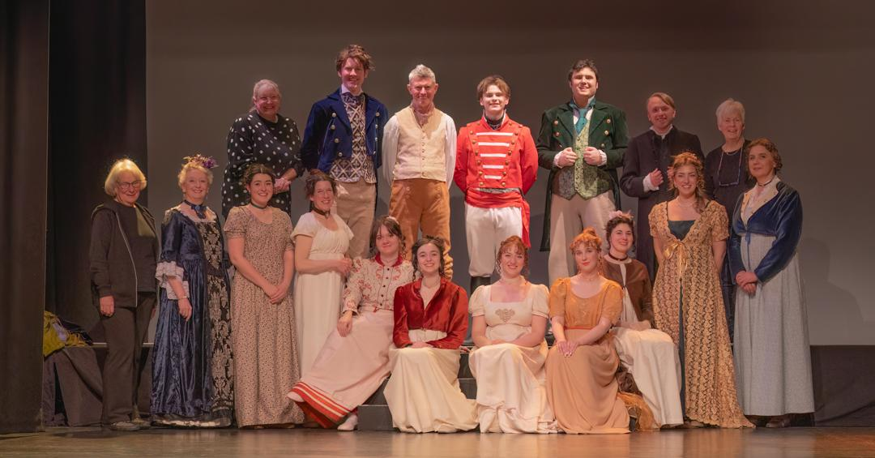

Based upon Jane Austen’s novel and adapted for stage by Brian J Burton, this production narrated so beautifully a tale that we Darcy fans could probably recite with our eyes closed, imagining Colin Firth climbing out of a lake! It had everything from witty exchanges and simmering tension, to grand balls and heartfelt moments of romance. The production effortlessly captured the charm and humor of Austen’s world, bringing to life the spirited Elizabeth Bennet played by Rosabelle Bennet, the brooding yet irresistible Mr. Darcy played by Matt Harvey, and the unforgettable cast of characters that make Pride and Prejudice such a timeless classic. With stunning period costumes, elegant staging, and a talented ensemble, it was a delightful retelling that had both devoted Austen fans and newcomers alike completely engrossed in the unfolding drama and romance.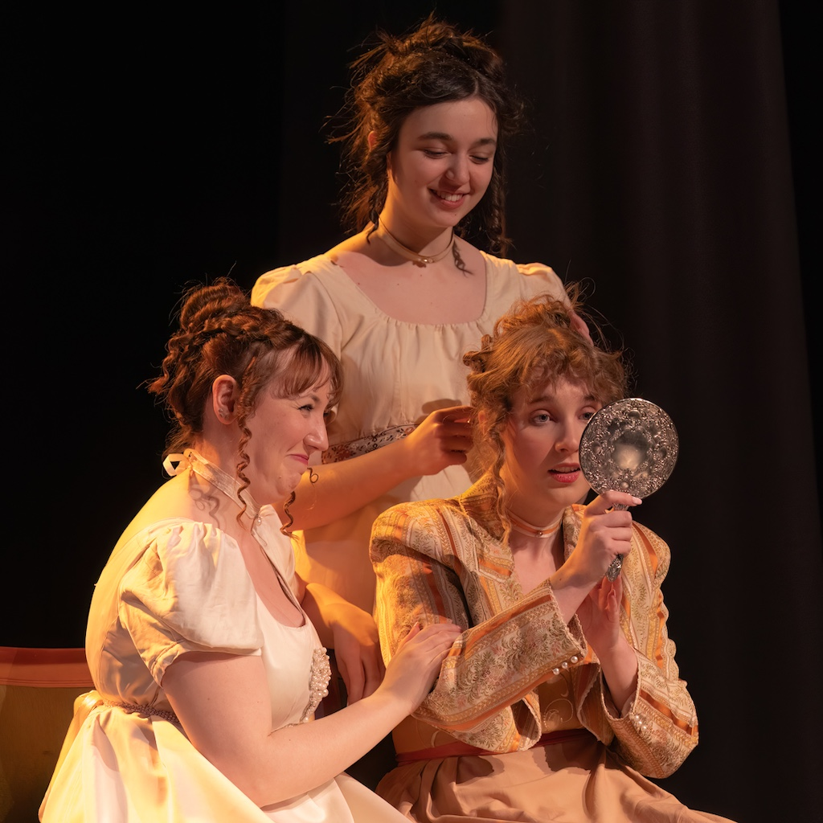

It has to be noted that one of the most striking elements of the production was the breathtaking period costumes, sourced by the talented Jenny Jones, who also embodied the role of the sharp-tongued and mean-spirited Caroline Bingley with great finesse. The costumes, hired from the esteemed Jane Austen Centre in Bath, added an extra layer of authenticity and elegance to the performance, transporting the audience straight into the refined world of Regency England. From the intricate detailing of the gowns to the crisp tailoring of the gentlemen’s attire, every outfit was a visual delight, capturing the era’s grace and sophistication. As I watched the story unfold, I truly felt as though I had stepped back in time, witnessing the romance and drama as if it were happening right before my eyes.

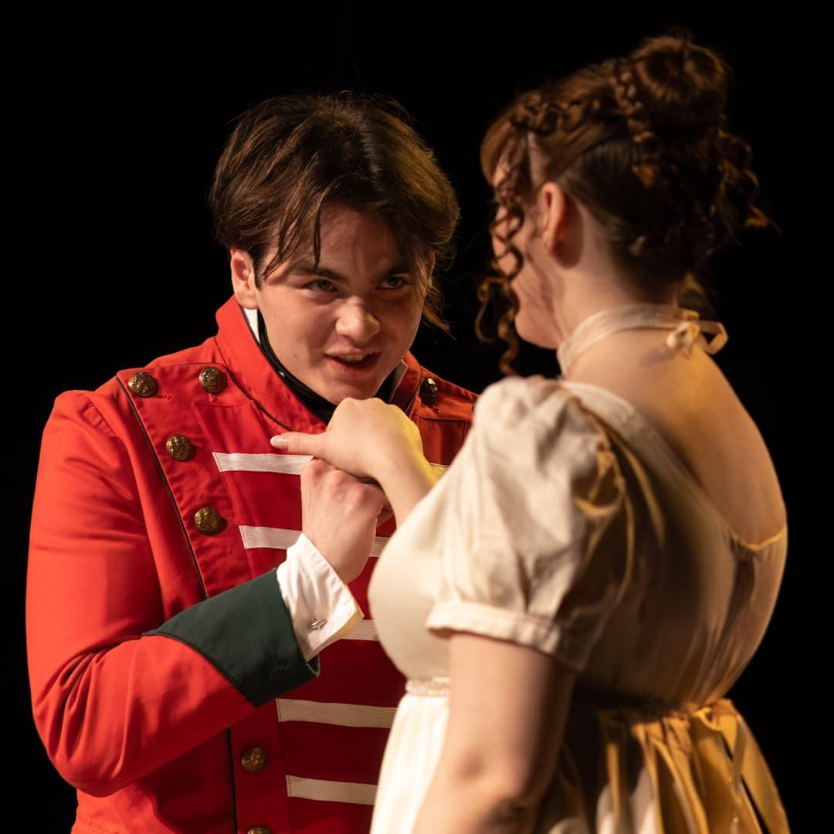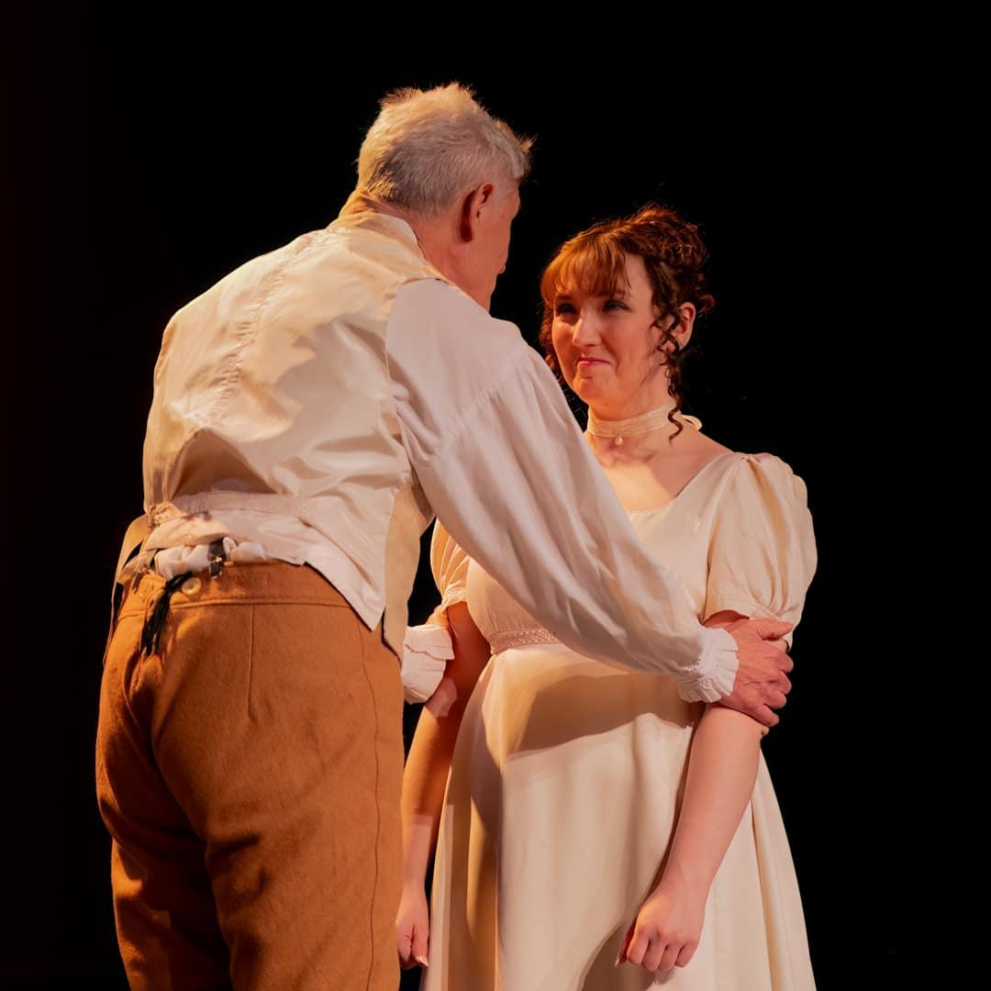

— and — vision for this performance was truly a breath of fresh air. As I entered the theatre, I was struck by an atmosphere that felt like a blend of Bridgerton meets Austen, and I couldn't help but feel like Lady Whistledown as I observed the buzz of excitement from the audience settling into their seats. Yet, dearest reader, this author has no negative comments to make about the performance she witnessed! The fluid movement of chairs, props, and actors, seamlessly navigated by Narrator Jane Austen, portrayed by Marie Williams, kept the story flowing effortlessly. The characters felt as though they were her beloved puppets, and I couldn’t help but feel as though I was experiencing the plot for the first time, guided by its very creator.

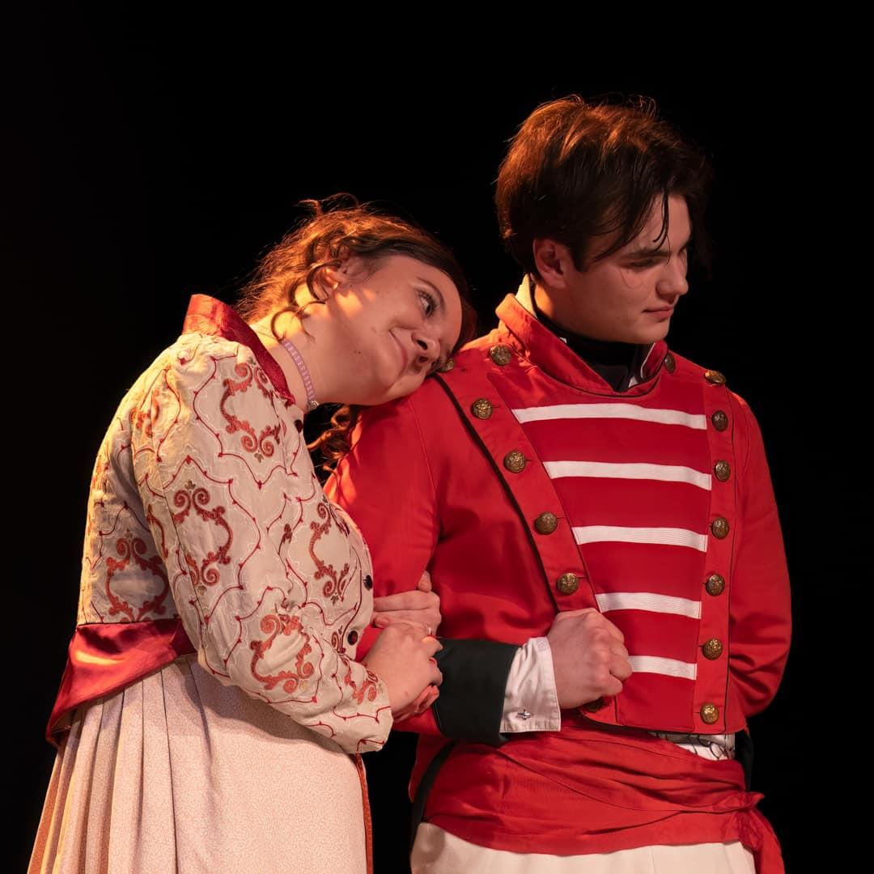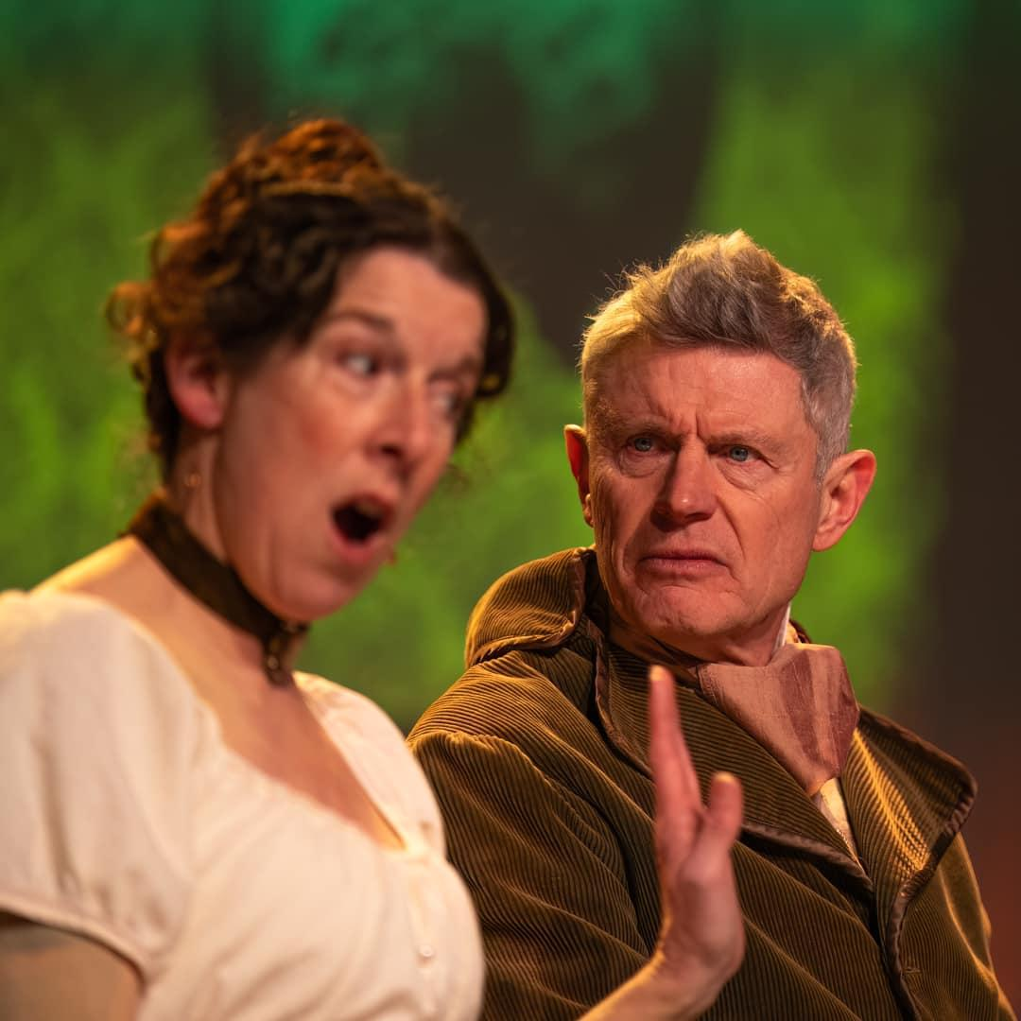

The set design was both inventive and effective, using clever projections and well-placed tabs and chairs to seamlessly immerse the audience into the various characters' homes. The contrast between settings was particularly striking - the lively, bright, and often chaotic Bennet household stood in sharp opposition to the gloomy, black-walled abode of Mr Collins. This stark difference not only served as a visual nod to the narrative but also added a touch of humor, as Mr Collins himself, played by Mike Jones, seemed to be a perfect reflection of his dull and dreary surroundings. The thoughtful design choices enriched the storytelling, subtly reinforcing the personalities and circumstances of the characters while keeping the transitions smooth and engaging. The use of light in this piece not only created the warm and cosy vibes that you would want from such a beloved story but I particularly enjoyed watching the passing of time with characters set in dim light whilst Jane Austen narrated. Every move from the actors seemed intentional, right down to moving chairs and all stayed in character so beautifully.

I was utterly impressed by Mat Harvey and Rosabelle Bennet’s impeccable timing, seamlessly delivering their lines in perfect harmony with the elegant rhythm of a quadrant Regency dance. The show’s blocking was fluid, ensuring a natural flow from scene to scene, while each moment was thoughtfully crafted with stolen glances and unspoken emotions that added depth to the storytelling. It was evident that every actor had been guided by intentional and meticulous direction, resulting in a cast that gelled beautifully on stage. One particularly memorable moment was the display of sisterly affection, shared giggles of embarrassment as Mr. Collins bumbled about, much to the audience’s delight. Mike Jones paid wonderful homage to this famously awkward character, capturing his absurdity with brilliant comedic timing.

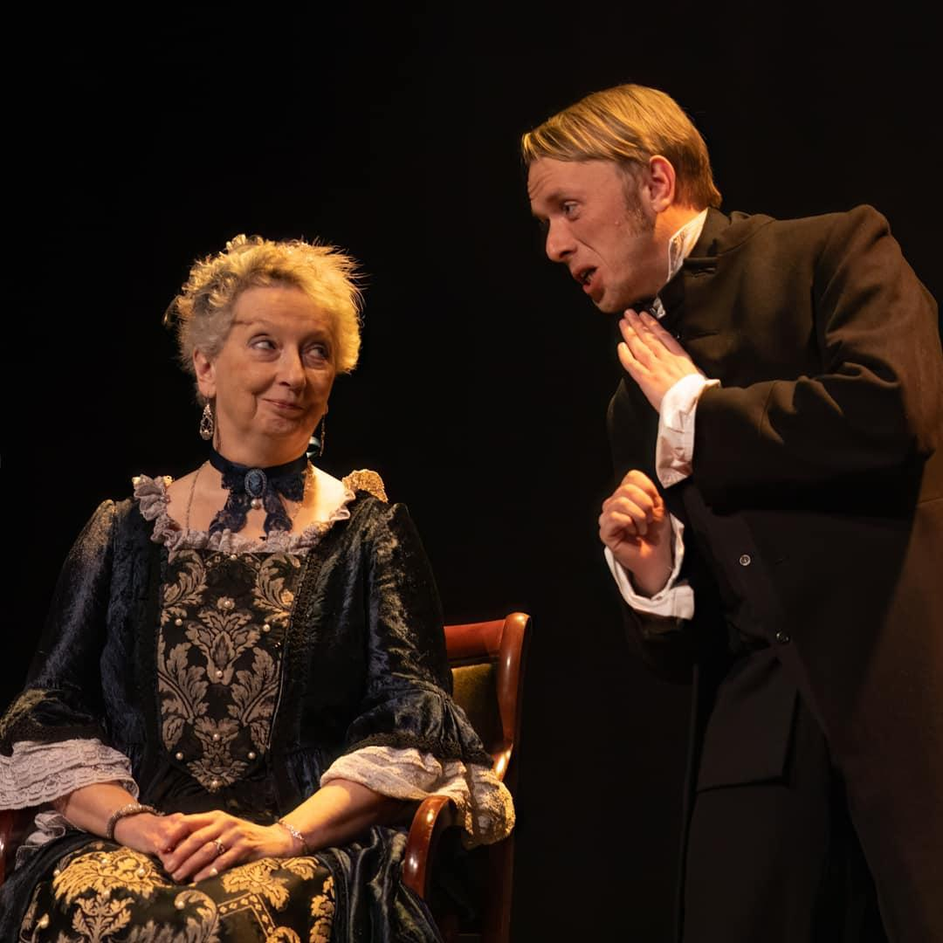

I must also highlight the unforgettable performances of Adelle Riley-Bell and Trevor Butlin as the infamous Mr. and Mrs. Bennet. Both actors embodied their roles to perfection, capturing every nuance of their characters with remarkable precision. Their onstage chemistry was an absolute delight, creating an authentic and often humorous glimpse into the lively chaos of the Bennet household. They bounced off each other effortlessly, bringing warmth and wit to their scenes, a hearty congratulations to them both for carrying the story with such care and charm.

And to our dear Lizzy, the beloved heroine who has captivated audiences for generations, what a stunning performance from Rosabelle Bennet. She portrayed Elizabeth with elegance, intelligence, and just the right touch of stubbornness that makes the second-eldest Miss Bennet so endearing. It was evident how much thought and effort had gone into shaping her performance, and Rosabelle’s dedication shone through in every moment she was on stage. A truly beautiful and heartfelt portrayal of one of literature’s most cherished characters.

I must extend my heartfelt congratulations to the entire cast, direction team, production team, crew, and committee for bringing this play to life with such skill and dedication. Staging *Pride and Prejudice* so beautifully is an achievement in itself, but to do so in the same week as World Book Day, during the 250th anniversary of Jane Austen’s birth, and (the most important bit…) during Bebington Dramatic Society’s 100th season of plays makes it all the more special. To the players and members past, present, and future - take a well deserved bow. What an incredible milestone! I hope everyone involved in this production, as well as those who have contributed to the society’s legacy over the years, feels immense pride in this accomplishment. I am truly grateful to have had the opportunity to support and celebrate this momentous occasion by watching one of my favorite stories so wonderfully retold.

I highly recommend catching Bebington Dramatic Society’s next performance, *The 39 Steps*, coming to the Gladstone Theatre in June 2025, I have no doubt it will be an absolute treat, packed with laughs from start to finish!

Reviewer: Rebecca Topping - AMT Productions

Date: 7/03/2025



**If you want to see Bebington Dramatic Society’s next production ‘The 39 Steps’ June 2025. Please follow the link below to book your tickets.**

[**https://gladstonetheatre.org.uk/events/the-39-steps/**](https://gladstonetheatre.org.uk/events/the-39-steps/)